**New Life At Calvary**

**September 15, 2024**

Prelude: Kerry Holland

Welcome /Opening prayer

Selection: *“Lift Up the Name of the Lord”*

Scripture: Ruby Turner

 OT: Genesis 16:7-15

   NT: Matthe 6:5-15

Offering

Special Selection: “O Happy Day” Praise Band

Message: The Always God “Always Seeing”

*Pastor Kellie*

Selection: *“Open The Eyes of My Heart”*

Brief Announcements

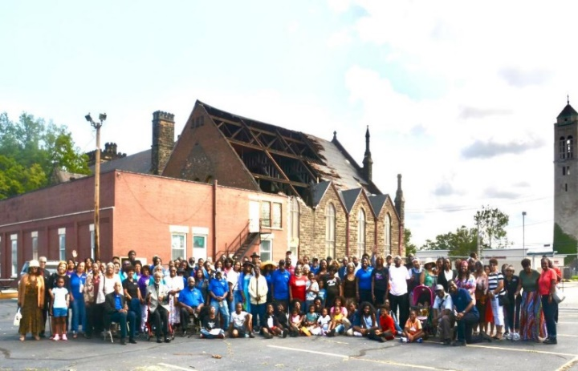Benediction

**Church Purpose**

In Response to God’s love, Our purpose is to love others, Teach the Word of God, and Reach World for Christ. Therefore, as a Covenant Partner, I will invite others to come and join me in worship. I will be a part of a small group bible fellowship to grow in Christ. I will serve in the ministry with my gifts and talents. I will do my part in faithfully giving my tithes and offerings to keep the ministry of Jesus Christ alive in the World. I will love all those who enter our doors and accept them in our midst.

**Lift Up the Name of the Lord**

*by**Shekinah Glory*

We've come to lift up the name of the Lord  
And sing praises, praises  
Lift up the name of the Lord  
And sing praises, praises  
Oh magnify the Lord with me  
Let us exalt His Name  
Lift up the name of the Lord  
And sing praises, praises

Repeat (3xs)  
  
Higher and Higher  
Come on and lift Him, come on and lift Him  
Repeat

Higher

**Open The Eyes Of My Heart**

Open the eyes of my heart, Lord,

Open the eyes of my heart;

I want to see You, I want to see You. (repeat)

To see You high and lifted up,

Shining in the light of Your glory.

Pour out Your pow’r and love;

As we sing holy, holy, holy. (repeat)

Holy, holy, holy;

Holy, holy, holy, I want to see You.

Open the eyes of my heart, Lord,

Open the eyes of my heart;

I want to see You, I want to see You. (repeat)

To see You high and lifted up,

Shining in the light of Your glory.

Pour out Your pow’r and love;

As we sing holy, holy, holy. (repeat)

Thank You for Your Goodness

Thank you for Your Kindness

Thank you for Your mercy

We want to see you.

High and lifted up.

**Announcements**

The Women’s Guild will meet on Tuesday, September 17th at 12:00 Noon.

Food Pantry – Friday, September 20th 10:00am. Volunteers are needed to help bring food into the gym and pack grocery bags.

Food Pantry – Saturday, September 21st 8:30am volunteers are needed to help distribute grocery bags.

Wade Park, Mr. Shakespeare, Family Support Specialist and Principal Dr. Charlene Hilliard send their thanks for all of the donations from NLAC. They are now focused on Children’s belts, underwear and socks.

Are you in need of a kid sized twin bed. We have a family donating a gently used twin bed that is in good condition. You must be able to pick the bed up. The bed has three drawers’ underneath. Please speak with Gail H. Banes if you are interested. Thank you.

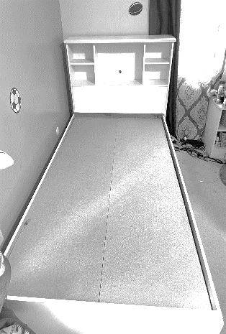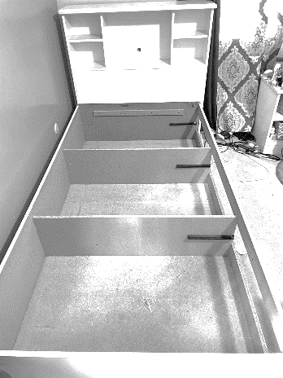

**Happy Birthday and Happy Anniversary**

**Birthday’s Week September 15th**

Joy Williams 16th

LaTanya Deane 19th

Andrea Billups 21st

**Anniversaries Week of the 15th**

Glynn & Emma Jackson 17th

**Scripture Readers Month of September**

Susan Gillespie 1st

Jessica Franklin 8th

Ruby Turner 15th

Ella Thomas 22nd

Latanya Deane 29th

**ALL LIFE CONNECT LESSONS ARE AVAILABLE TODAY!**



**Youth Zoom Classes on Mondays**

**Worship September 16th**

**Teacher (Pastor Antonia Martin)**

(Grades PK-K) 2-5 years (6:00-6:30 pm)

(Grades 1-3) 6-8 years (6:30-7:30 pm)

(Grades 4-6) 9-12 years (7:30-8:30 pm)

(Grades 7-12) 13-17 years (8:30-9:30 pm.)

Zoom ID: 832 7903 1773 PC: 092683

**Monday 6:30 pm (Adult Class)**

**The Good Gospel**

**Teachers: Marvin Rogers and Andrea Billups**

Zoom Meeting 891-1091-7393/2020 Zoom Call In 1-312-626-6799 891-1091-7393 # # 2020#

**2nd Tuesday 7:30 pm (Women) Monthly**

**October 8th**

Teacher: Helen Britt (Women with a Heart Bent Toward God) Zoom Meeting 891-6849-5855 PC: 751319

**Wednesday 7:30pm (Adult Class)**

**Teacher: Pastor Antonia**

Zoom Meeting 829-8003-5837/2020 Zoom Call In 1-312-626-6799 829-8003-5837 # # 2020#

**Wednesday 7:30 pm (Adult Class)**

**Worship in the Covenant Community**

**September 18th**

**Teacher: Sylvia Fields**

Zoom Meeting 865-9998-5439/54321

Zoom Call In 1-301-715-8592 ID: 865-9998-5439 # # PW: 54321 #

**Wednesday 7:00 pm (Adult Class)**

Teachers: Reginald Woods – Romans

In person in the gym. **Sept. 11th**

**Wednesdays 7:00 pm (Adult Class)**

**September 18th**

**Teacher: Pastor Toby Emeritus (The Chosen Season 4)** Zoom Meeting 334-158-729/2020 Zoom Call In 1-312-626-6799 334-158-729# # 2020#

**Read The Bible in One Year/52 weeks/365 days**

**- 7:00 pm September 17th WK 41-2 Chr. 16-20**

We will be using the NIV Version –

Teacher: Pastor Kellie

Meetings 1st, 3rd, 4th & 5th Tuesday of the month

Meeting IDD: 82097918709 PW: 605886

Phone# 13126266799 82097918709 # # 605886 #

**Everyone should have read up to week 40**

**Special Offerings**

**1st Sunday – Deacon’s Offerings**

**2nd Sunday – Prison Ministry**

**3rd Sunday – Rotolu Orphanage Nigeria**

**4th Sunday – Two Cents A Meal**

**5th Sunday – Above & Beyond**

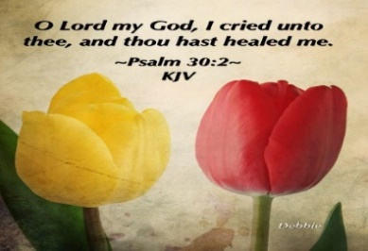

*Please send a card, call, pray for, and support our Sick and Shut ins and recuperating brothers and sisters in Christ. Thank you.*

**Joseph Banaci (**Cedarwood Plaza, 12504 Cedar Rd. #111, Cleveland, Oh 44106)

**Jennie Brown** (1783 East 227th St, Euclid, OH 44117 216.785.9295)

**Stanette (Brown) Israel** (19205 Lanbury Ave, Warrensville, OH 44122) 216-798-6223 cell: 216.941.5211)

**Bessie Bryant** (Jennings Rehab Center, 10210 Granger Rd, #367 Garfield Hts 44125 216-246-3453)

**Minnie Doaty** (12005 Ablewhite Ave, Clev., OH 44108)

**Natalie Franklin** (daughter of Julie Wright cards only) (c/o Donnese Franklin, 4216 Colby Ave, Columbus, OH 43227)

**Alfred Haywood** (St. Augustine 7801 Detroit Ave, Rm 421, Cleveland, OH 44102)

**Savannah (Robin) Hill** (Falling Water Healthcare Center, RM 236D, 18840 Falling Water Rd. Strongsville, OH 44136)

**Glynn Jackson** (13717 Southview Clev., OH 44120 216-921-3788)

**LaDonna Jessup** (Shaker Gardens Nursing & Rehab. 3550 Northfield Rd – 362BA – Shaker, OH 44122 - 216-255-7693)

**Kent Kelton** (9308 Empire, Cleveland, OH 44108 216-287-0469)

**Mildred Little** (1344 East 90th St., Cleve., OH 44106)

**Elosie Payne** (Jennings Rehab Center, 10204 Granger Road, Rm 110 Garfield Hts 44125)

**Martha Robinson** (LECOM at Elmwood Gardens, 2628 Elmwood Ave., Erie, PA 16508)

**Fannie Ruffin** (8164 Dartmoor Rd, Mentor, OH 44060)

**Anna Sharp** (Home 216- 921-6835)

**Edna Swoope** (27100 Cedar Rd, Beachwood, OH 44122)

**Brenda White** (West Park Commons 4106 Rocky River Dr, Apt 207, Clev., OH 44135 216-377-7352)

**Delois Williams** (1007 East Blvd, Cleveland, OH 44108)

**Janet Williams** (10516 Elgin Ave., Clevland, OH 44108)

**Kathlyn (Benita) Williams** (1007 East Blvd, Cleveland, OH 44108)

**Marvin A. Hayes** V.A. Hospital University Circle (10701 East Blvd. Cleveland, OH

**`**



**The White pillars candle in the chancel is a reminder for us to pray for the safety of all the men and women serving in the military. It reminds us to pray for peace in our land and all lands.**

**Sermon Series: September**

**9/1: The Always God: Always Speaking**

**9/8: The Always God: Always Hearing**

**9/15: The Always God: Always Seeing**

**9/22: The Always God: Always Pursing**

**9/29: The Always God: Always Restoring**



**WE VOTE AT NEW LIFE AT CALVARY**

New Life At Calvary is encouraging everyone to VOTE this November in our election. We encourage you to vote every election. If you need help, Lay Pastor Sylvia Y. Fields and Elder Yvonne Sims are here to help you each Sunday after church. Here is the information from our Cuyahoga County Board of Elections:

**VOTE Cuyahoga County Board of Elections**

**2024 General Elections: November 5, 2024**

Deadline to Register to Vote: October 7, 2024 (Boards open until 9:00 PM)

Early In-Person Voting: October 8 and includes two Saturdays and the two Sundays before the Election Day.

Absentee Voting By Mail: Begins October 8, 2024

Election Day: November 5 (Polls Open 6:30 am to 7:30 pm) If not returned by mail, absentee ballots must be received by your board of elections by 7:30 pm

Important Dates:

October

* October 7: Deadline to Register to vote. Boards open until 9:00 pm
* October 8: Abseentee Voting by Mail begins (Ends November 4, postmark deadline)
* October 8: Early In-Person Voting Begins
* October 29: Absentee ballot applications must be received by your board of elections by 8:30 pm

Early In-Person Voting Hours for October and November

* October 8-11: 8:00 am – 5:00 pm
* October 14-18: 8:00 am - 5:00 pm
* October 21-25: 8:00 am - 6:00 pm
* October 26: 8:00 am – 4:00 pm
* October 27: 1:00 pm – 5:00 pm
* October 28: 7:30 am – 7:30 pm
* October 29: 7:30 am -8:30 pm
* October 30 – November 1: 7:30 am -7:30 pm
* November 2: 8:00 am – 4:00 pm
* November 3: 1:00 pm -5:00 pm

**November**

November 4: Mailed absentee ballots must be postmarked by this date.

November 5: General Election: Polls are open from 6:30 am – 7:30 pm

Novemer 5: Absentee ballots must be returned by mail or personally delivered to your county board of elections. If not returned by mail, absentee ballots must be received by your bo

ard of elections by 7:30 pm

November 9: Last day for boards of elections to receive absentee ballots that have been postmarked on or before November 4.

**New Life At Calvary**

**is participating in our Congresswoman, Shontel Brown’s initiative**

**SOULS TO THE POLLS 2024.**

**We are one of 100 churches mobilized to assist our community with voting with a special emphasis on mail-in-voting. Sign up today to receive your mail in ballot.**

**How can you help with voter turn out?**

1. Sign up to drive on the two Sundays before the election (October 20th and October 27th). After church we need help driving. Help us drive our fellow citizens downtown to the Board of Elections. Take them home afterwards.
2. Help Lay Pastor Sylvia and Elder Yvonne by assisting our congregation members that are eligible to vote to register.
3. Talk to your family memers and friends and help the register to vote. Talk to everyone and encourage them to vote.

Christians loving each other through the election! At New Life At Calvary we encourage everyone to love, support, and encourage each other no matter what our political beliefs might be. We have persons of all political persuasions at NLAC. We have Democrats, Republicans, Independents and Non-Voters. As American Citizens, we all have the freedom to have our own thoughts, ideas, and beliefs. Through the election lets remember to Love our Neighbor!

**PROJECT 2025** Many have asked for information about Project 2025. As a church we are allowed to provide information only. The church has no opinion on any political matters. There is a flyer with an explanation of Project 2025 available on the information station. If you would like to share information about political matters that are imporatant to you, please bring in a copy of the material and we will share it.

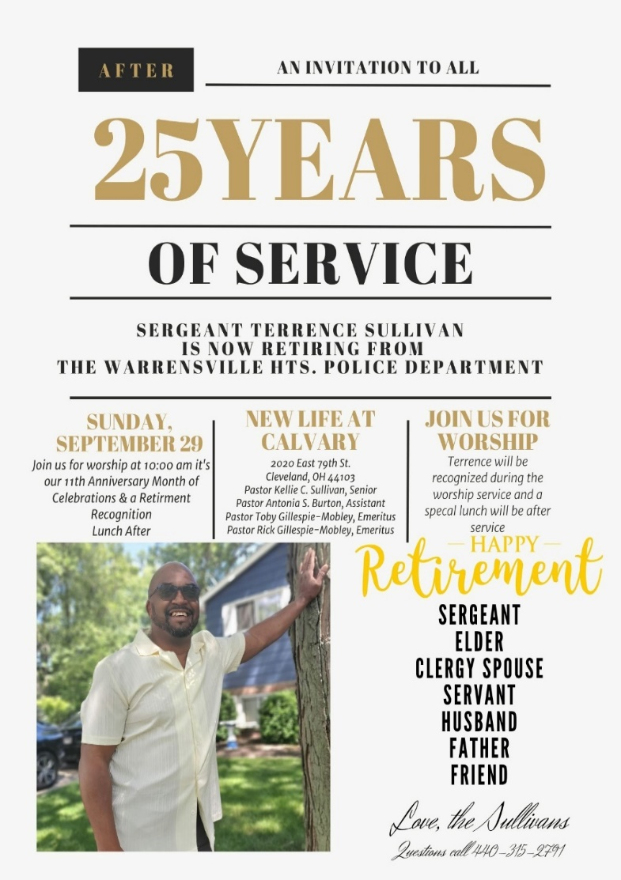

Candy! Candy! Candy!

Donate individually wrapped candy for our All Saints Day Worship Service

We want to fill up the kids bags with all kinds of treats and/or prizes. Donate today. You can also donate financially in your offering towards the cost of the candy.

We appreciate your support!

Thank you!

**All Saints Worship Service**

Join us on

Sunday October 27, 2024 for our

All Saint’s Day Worship Service

This is our Halloween Alternative. We will not have Trunk or Treat this year!

This is a reminder of those who have died for the Cause of Christ!

Those who, like our Lord, gave their lives for the Gospel Message.

We are asking our youth to participate in service by reading scripture, singing, serving as ushers/greeters.

Donate Candy to this special day.

All youth will receive a bag of Candy after the service.

**New Life At Calvary 9th Anniversary Celebration Sundays**

Thank you to all who helped with the 11th Anniversary Celebration Anniversary Luncheon and Picnic. Thank you to the pastors; Pastor Kellie and Pastor Antonia, the Deacons (Clemon Walker, Trinity Sullivan, Reginald Woods, Tina Williams, Unique Willis-Norris, Joseph Stewart, Tina Williams, David Blackshire, the Elders & Celebration Committee (Sylvia Fields, Ruth Yarbrough, Marian Wallace, Helen Britt, Ella Thomas, Yvonne Sims, Sharon Thomas, Ruby Turner) and those that just pitched in to help. Thank you to Mary James, Vanessa Jenne, Shannon Hendrix, Glenn Hendrix, Michal Milan, Terrence Sullivan, II, Caiden Kingsbury, Dallas Taylor, James Taylor, Alyse Breeding, Phoenix Breeding, DeKari Avery, Amari Rouse, Averee Thomas for your help. Thank you

Our 3rd Sunday 11th Anniversary Worship Service, 9/22/2024 Pastor Keon Abner from Bridge City Church will be preaching!

**________________________________________________________________________________________**

**John Bruere Scholarship Fund Applications:**

We thank God for the opportunity to bless our college and graduate students with scholarships.

The John Bruere Scholarship Fund Applications will be available by the end of the month. Please stay tuned for further information.

**A HUGE THANK YOU!**

Pastor Antonia and Sabastian sent a GREAT BIG CARD to New Life At Calvary. It says, “Thank You So Much. New Life At Calvary, This calls for a HUGE amount of Gratitude. We are so grateful for you. Thanks to everyone for being a blessing in our time of loss. God Bless You All, Pastor Antonia and Sabastian Burton.

The card is hanging on the wall in the back of our Gymuary.

**Building Update**

Session has approved us working with a new General Contractor called Korner Construction, owned by Todd Korner. Todd has submitted a detailed scope of work. We are waiting for the insurance company, Church Mutual, to approve his plan and get started on the work. We thank God for these next steps.

