**New Life At Calvary**

**Communion Sunday**

**March 2, 2025**

Prelude: Kerry Holland

Welcome/Opening Prayer:

Selection: Praise Team

*“Hallelujah Your Worthy To Be Praised”*

Scripture: Sharon Thomas

*OT: Isaiah 59:1*

*NT: Ephesians 3:14-21*

Offering:

Special Music: Praise Band

*“Where He Leads Me”*

Message: A Love That Surpasses Knowledge:

*“Rooted & Established in Love”*

***Pastor Antonia***

Selection: *“This I Believe & Thank You Lord”*

The Sacrament of Holy Communion

Announcements:

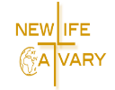Benediction:

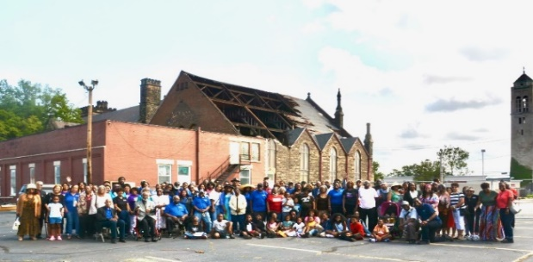

**Church Purpose**

In Response to God’s love, Our purpose is to love others, Teach the Word of God, and Reach the world for Christ. Therefore, as a Covenant Partner, I will be a part of a small group bible fellowship to grow in Christ. I will serve in the ministry with my gifts and talents. I will do my part in faithfully giving my tithes and offerings to keep the ministry of Jesus Christ alive in the World. I will love all those who enter our doors and accept them in our midst.

**Hallelujah Your Worthy to be Praised**

Hallelujah you’re worthy to be

praised! (x8)

I lift my hands I praise you lord

I bow my head I honor you lord

I lift my hands I praise you lord

I bow my head I honor you lord

Hallelujah you’re worthy to be praised

Hallelujah you’re worthy to be praised

Hallelujah you’re worthy to be praised

Hallelujah you’re worthy to be praised

I lift my hands I praise you lord

I bow my head I honor you lord

I lift my hands I praise you lord

I bow my head I honor you lord!

Hallelujah you’re worthy to be praised

Hallelujah you’re worthy to be praised

Hallelujah you’re worthy to be praised

Hallelujah you’re worthy TO BE

PRAISED!...

Hallelujah you’re worthy!

Hallelujah, we praise your name

Hallelujah so worthy

Hallelujah, lord we lift you up!

Hallelujah you’re worthy!

Hallelujah, we praise your name

Hallelujah so worthy

Hallelujah, lord we lift you up! (x3)

ALL

Hallelujah you're worthy!

Hallelujah, we praise your name

Hallelujah so worthy

Hallelujah,

Lord, we lift you up!

Hallelujah you're worthy!

Hallelujah, we praise your name

Hallelujah so worthy

Hallelujah,

Lord, we lift you up!

LORD, WE LIFT YOU UP

LORD, WE LIFT YOU UP

LORD, WE LIFT YOU

UP!!!!!!!!!!!!!!!!!!!!!!

**Selection:** “This I Believe”

I believe in God our Father

I believe in Christ the Son

I believe in the Holy Spirit

Our God is three in one

I believe in the resurrection

That we will rise again

For I believe in the Name of Jesus

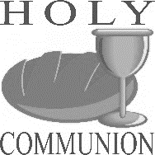**Communion Service**

***(Examination of our Hearts)***

L. Here what Jesus Christ promises: Happy are those who hunger and thirst for what is right. They shall be satisfied.

**P. Jesus said, “I am the bread of life. The one who comes to Me will never be hungry. The one who believes in Me will never thirst.**

L. This is also the word of the Lord: “All those whom I love, I correct and discipline. Therefore, shake off your complacency and repent. See I stand knocking at the door

If anyone listens to My voice and opens the door, I will go in and dine.”

**P. Let us open our hearts to the Lord. Let us open every door of our lives to God.**

L. Lift up your hearts.

**P. We lift them to the Lord.**

L. Holy God: We praise You for Your Son Jesus, who shared our weakness, and was tempted in every way as we are; Who obeyed You by suffering and dying for us. You have raised Him to rule The world and have given Jesus a name above every name, Lord And Christ. We praise Him, and we glorify You. Great God our Creator.

**P. Now give us Your Spirit in the breaking of bread and sharing of the cup, So that by Your power, we may be drawn together and made one with Jesus, Who is the Way, the Truth, and the Life.**

**Unison:** Our Father, who art in heaven, hallowed be Thy Name. Thy kingdom come. Thy will be done on earth as it is in heaven. Give us this day, our daily bread. And forgive us our debts, as we forgive our debtors; and lead us not into temptation. But deliver us from evil. For thine is the kingdom and the power and the glory forever. **Amen.**

**The Words of Institution ~ The Distribution**

**Prayer of Thanksgiving: (Unison)**

Bountiful God, we give you thanks that you have refreshed us at your table by granting us the presence of Christ. Strengthen our faith, increase our love for one another, and send us forth into the world in courage and peace, rejoicing in the power of the Holy Spirit. **Amen**

**Thank You Lord**

Thank You, Lord, thank You, Lord,

Thank You Lord,

I just want to thank You, Lord.

Been so good, been so good,

Been so good,

I just want to thank You, Lord

**Announcements**

Attention: Please refrain from walking during these times: Prayer, Soloist, Scripture and Sermon. Thank you.

NLAC Annual Congregational Meeting has been rescheduled for Sunday, March 16, 2025 after worship service.

Grief Share is beginning at Bay Presbyterian Church, Sunday evenings at 6pm. It is a program

that is national and is done as a group. Please see Pastor Antonia if you are interested.

The Chairlift is available for use. Please see one of the Ushers, Terrence or Jayden if you need help.

**Birthday The Week of March 2, 2025**

Sharon Grice-Williams 3rd

Kadira Gulley 3rd

Avree Thomas 3rd

Kiana Jackson 7th

Alfred Haywood 8th

**Scripture Readers March**

Sharon Thomas Mar. 2nd

Ella Thomas Mar.9th

LaTonya Deane 16th

Reginald Woods 23rd

Ruby Turner 30th

**Special Offerings**

**1st Sunday – Deacon’s Offerings**

**2nd Sunday – Prison Ministry**

**3rd Sunday – Rotolu Orphanage Nigeria**

**4th Sunday – Two Cents A Meal**

**5th Sunday – Above & Beyond**



**Sermon Series February/March**

**A Love That Surpasses Knowledge**

2/16 Breaking Down Walls

2/23 From Excluded To Included

3/2 Rooted & Established In Love

3/9 Speaking Truth Bombs

3/16 Trade Secrets

3/23 Fail More

**“Breaking Down Walls” 2/16/25**

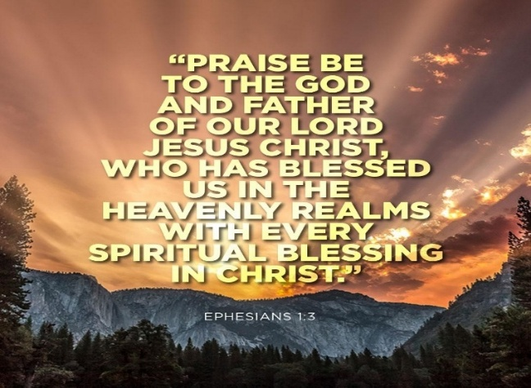

**“From Excluded to Included” 2/23/25**

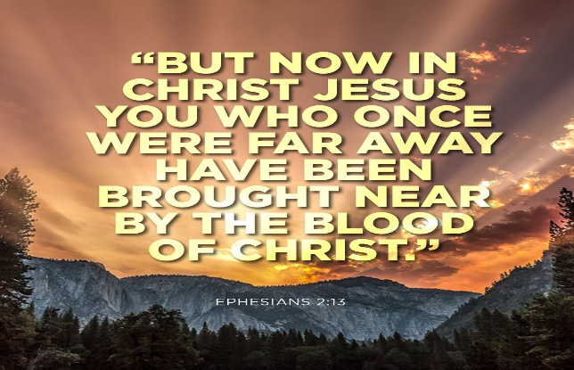



Ash Wednesday, the start of Lent, is on March 5, 2025. Ash Wednesday is a day of repentance and fasting that marks the beginning of Lent, a 40-day period leading up to Easter. Lent is a period of prayer, fasting, and giving for Christians.

**Unconventional Things to Give Up for Lent**

* Gossip
* Shopping (everything but the essentials – buy only food, gas for your car, pay your bills…)
* Facebook
* Television (use the time to read a book or connect with other people)
* Netflix (same)
* Driving (walk, bike, or take the bus instead)
* Criticism and Complaining
* Pride
* Stop Worrying
* Wearing Make-up
* Unforgiveness

**Things to do During Lent**

* Prayer
* Memorize Scripture
* Gratitude Journal
* Forgiveness
* Donate to a Charity
* Start a Devotion
* Exercise
* Text Prayers
* Confess to the Lord in Prayer
* Show Kindness
* Check on someone
* Meditate
* Attend Church

* Smoking
* Drinking Alcohol
* Talking about yourself (unless someone asks you a direct question)
* Stop skipping church
* Video games/games on your phone
* Sleeping in/staying up late (use that time to read your Bible)
* Your smart phone (except for calling people – no social media, no silly cat videos – connect with real humans instead)
* Fast food
* Interrupting people
* Attend Bible Study
* Have a fish fry and invite friends and family
* Volunteer
* Participate in a spiritual book club
* Get to know your neighbors
* Get to know your church members
* Read your bible
* Make a point to learn more about a particular social issue (immigration, human trafficking, racism the environment, public education child poverty). Give to an organization

***NEW LIFE AT CALVARY CELEBRATES A POWERFUL RETURN!***

*“****Restoring the Sanctuary, Rebuilding Our Spirit”***

*New Life At Calvary is thrilled to announce our return to the Sanctuary after 17months of worshiping in our Gym due to the devastating EF-1 tornado on August 24,2023. Through prayer, resilience, and God’s grace, we’ve made incredible progress in our restoration journey, and we’re excited to welcome you to a week of transformative events.*

**Here’s What’s Happening The Week of March 2nd.Sunday, March 2, 2025 Final Worship Service in the Gym**

*Time: 10:00 AM*

*Details: Join us for our last worship service in the gym, concluding with a Solemn Prayer Walk to the Sanctuary. Each participant will receive a prayer card for reflection and intercession as we gather to pray over our renewed space.*

**Wednesday, March 5, 2025 Ash Wednesday Services**

*Times: 12:00 PM & 6:30 PM*

*Details: Join us as we reflect and repent during this Holy day. Services will*

*include uplifting music, a message of renewal, and light refreshments as we welcome the community to share in the joy of our restored Sanctuary.*

**Sunday, March 9, 2025 Return to Worship – Our First Full Sunday Service in the Sanctuary**

*Time: 10:00 AM*

*Details: Join us as we experience the joy of worshiping in our sanctuary once again. This momentous service will be filled with gratitude, praise, and hope for the future.* **Come Celebrate with Us!** *Through God’s grace and your generosity, our Sanctuary stands strong once again. Let’s come together to honor this new chapter in the life of New Life At Calvary!* **New Life At Calvary | Restoring Faith, Together** *For more information, visit www.nlac.tv address: 2020 East 79th St. Cleveland, OH 44103 216-391-8448*

**Youth Zoom Classes on Mondays**

**Worship Class – A King Forever and Ever**

**Teacher (Pastor Antonia Martin)**

(Grades PK-K) 2-5 years (6:00-6:30 pm)

(Grades 1-3) 6-8 years (6:30-7:30 pm)

(Grades 4-6) 9-12 years (7:30-8:30 pm)

(Grades 7-12) 13-17 years (8:30-9:30 pm.)

Zoom ID: 832 7903 1773 PC: 092683

**Monday 6:30 pm (Adult Class)**

**Gratitude Is Not Thanksgiving**

**Teachers: Marvin Rogers and Andrea Billups**

Zoom Meeting 891-1091-7393/2020 Zoom Call In 1-312-626-6799 891-1091-7393 # # 2020#

**Women with a Heart Bent Towards God**

**Teacher: Helen Britt**

**2nd Tuesday of the Month March 11th**

**Wednesday 7:30pm (Adult Class)**

**The Beatitude Project (On Break Ash Wednesday)**

**Teacher: Pastor Antonia –**

Zoom Meeting 829-8003-5837/2020 Zoom Call In 1-312-626-6799 829-8003-5837 # # 2020#

**Wednesday 7:30 pm (Adult Class)**

**Teacher: Sylvia Fields (On Break 2/26 & 3/5)**

**A King Forever and Ever**

Zoom Meeting 865-9998-5439/54321

Zoom Call In 1-301-715-8592 ID: 865-9998-5439 # # PW: 54321 #

**Wednesday 7:00 pm (Adult Class)**

Teachers: Reginald Woods – Romans Part 2

In person in the gym.  **(on Break Ash Wednesday)**

**Wednesdays 7:00 pm (Adult Class)**

**Teacher: Pastor Toby Emeritus (The Chosen Season 4 Episode 8)** Zoom Meeting 334-158-729/2020 Zoom Call In 1-312-626-6799 334-158-729# # 2020# **(On Break Ash Wednesday)**

**Read The Bible in One Year/52 weeks/365 days - 7:30 pm**

**Genesis Chapter 1 V25**

We will be using the NIV Version –

Teacher: Pastor Kellie

Meetings 1st, 3rd, 4th & 5th Tuesday of the month

Meeting ID: 82097918709 PW: 605886

Phone# 13126266799 82097918709 # # 605886 #

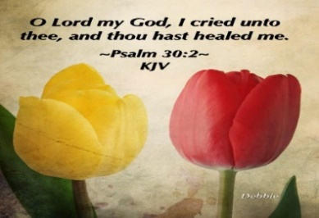

*Please send a card, call,* *pray for, and support our Sick and Shut ins and recuperating brothers and sisters in Christ. Thank you.*

**Jennie Brown** (1783 East 227th St, Euclid, OH 44117 216.785.9295)

**Stanette (Brown) Israel** (Ave. at Warrensville Care & Rehab, 4129 Interchange Corporate Center Rd. #143, Cleveland, OH 44128, 216.941.5211)

**Bessie Bryant** (Jennings Rehab Center, 10210 Granger Rd, #367 Garfield Hts 44125 216-246-3453)

**Minnie Doaty** (12005 Ablewhite Ave, Clev., OH 44108)

**Natalie Franklin** (daughter of Julie Wright cards only) (c/o Donnese Franklin, 4216 Colby Ave, Columbus, OH 43227)

**Marvin Hayes** (1817 Marloes East Cleveland, OH 44112

216.650.2312)

**Alfred Haywood** (St. Augustine 7801 Detroit Ave, Rm 421, Cleveland, OH 44102)

**Savannah (Robin) Hill** (Falling Water Healthcare Center, RM 236D, 18840 Falling Water Rd. Strongsville, OH 44136)

**LaDonna Jessup** (Shaker Gardens Nursing & Rehab. 3550 Northfield Rd – 362A – Shaker, OH 44122 - 216-255-7693)

**Kent Kelton** (9308 Empire, Cleveland, OH 44108 216-672-2763)

**Mildred Little** (1344 East 90th St., Cleve., OH 44106)

**Fannie Ruffin** (8164 Dartmoor Rd, Mentor, OH 44060)

**Edna Swoope** (27100 Cedar Rd, Beachwood, OH 44122)

**Brenda White** (West Park Commons 4106 Rocky River Dr, Apt 207, Clev., OH 44135 216-377-7352)

**Janet Williams** (10516 Elgin Ave., Clevland, OH 44108)



**The White pillars candle in the chancel is**

**a reminder for us to pray for the safety of all**

**the men and women serving in the military.**

**It reminds us to pray for peace in our land**

**and all lands**

**Pledge Card for support of the 2nd Milestone of the**

**Building On Faith Capital Campaign of**

**New Life At Calvary Cleveland, OH**

A Capital Campaign is how we fund the future of New Life At Calvary. It challenges us to reach higher and dig deeper in order to meet the immediate and long-term needs of the church and the community. Like annual giving, giving to a Capital Campaign enhances the mission and ministry of the church through renovation and improvement of our church building.

Giving to the Capital Campaign is considered sacrificial giving. It does not come from our daily living expenses. Capital Campaign giving can be spread out over a three-year period to allow donors to manage their gifts according to their needs.

_____________________________________________________________________________

**I/We pledge in faith to support the 2nd Milestone of the Capital Campaign of New Life At Calvary listed by making the financial contribution listed below:**

**Total Amount of Pledge $_________________** (for those renewing the pledge see reverse side of this form)

**One-time Payment Date: ___________ Payments Over-Time**

Regular Payment Schedule expected:

$_____________ each week/month/quarter/year

**Method(s) of Payment**

* Cash or Check Enclosed
* Online Giving through New Life At Calvary
* (set up on the [www.nlac.tv](http://www.nlac.tv) website)
* Gift of Securities (see other side for more ways to give)

Start date: ______________ End Date: ______________

-or-

Other Payment Schedule described below:

__________________________________________________

__________________________________________________

__________________________________________________

Names: _____________________________________________________________________________________________________

Address: ____________________________________________________________________________________________________

City: _______________________________________________ State: __________________ Zip: ____________________________

Phone: ______________________________________________ Email: _________________________________________________

Signature Date of Pledge

____________________________________________________________________________________________________________

Signature Date of Pledge

**Methods of Giving to New Life At Calvary Capital Campaign, *Building on Faith Restoration***

**Cash or Checks**- Checks payable to New Life At Calvary, sent to 2020 E. 79th Street, Cleveland, Ohio 44103

**Online Giving**- One time or Recurring payment directly from a bank account. This is set up and managed from the Online Giving tab on the New Life At Calvary website (nlac.tv).

**Gifts of Securities**- Gifts of stocks, bonds, and other financial instruments can be arranged by contacting the NLAC steering Committee: Pastor Kellie C. Sullivan, Sylvia Y. Fields, Ruby Turner and Ella Thomas. When giving gifts of securities, please contact the Steering Committee with the donor’s name, the type of security name, and the number of shares, no later than the day the gift is made.

**Matching gifts**- Many employers will match charitable donations made by their employees. By using your company’s Matching Gift benefit, you may be able to multiply the amount of your donation. If you are affiliated with a company that matches gifts, please send the Matching Gift Form (usually attained by contacting your Human Resources Department), along with your donation to New Life At Calvary. The church will complete the form and return it to the company.

**Information pertaining to my companies matching gift program:**

___ I/We work for a Company that has a Matching Gifts Program.

___ The Matching Gifts Form is enclosed with this Pledge Card.

___The Matching Gifts form will be forwarded in the near future.

------------------------------------------------------------------------------------------------------------------------------------------

I/We pledge in faith to support the *Building on Faith Restoration Campaign* of New Life At Calvary by making the financial contribution listed on the reverse side of this form. My/Our contact information is on the reverse side. I/We have also signed indicating our commitment to complete this pledge. I understand that if we are a couple making this pledge both parties must sign this pledge.

**I/We made a pledge to the 1st Milestone. For the 2nd Milestone please do one of the following: (Check One)**

1. __________ Keep my/our pledge the same.
2. . _________ Increase my/our pledge to $________________.
   1. I/We plan on giving monthly, weekly, bi-weekly (please circle one).
3. I /We want to discuss giving a **Gift of Securities.**
4. I/We want to discuss doing a matching gift with my job.

1st Milestone givers please complete the contact information on the other side of this form. Thank you for your continued support.