**New Life At Calvary**

**Communion Sunday**

**February 2, 2025**

Prelude: Kerry Holland

Welcome/Opening Prayer

Selection: Praise Team

*“Let It Rise”*

Scripture: Susan Gillespie

*OT: Ecclesiastes 3:1*

*NT: Ephesians 5:15-16 & 2Peter 3:8*

Offering:

Special Music:

*Anna Sakairoun & Valencia Oliver*

Message: Win The *Day “Making Time For*

*God” Pastor Antonia*

Selection: *“This I Believe”*

The Sacrament of Holy Communion

Announcements:

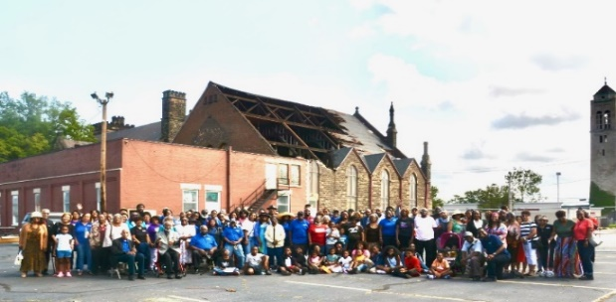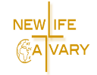Benediction:

**Church Purpose**

In Response to God’s love, Our purpose is to love others, Teach the Word of God, and Reach the world for Christ. Therefore, as a Covenant Partner, I will be a part of a small group bible fellowship to grow in Christ. I will serve in the ministry with my gifts and talents. I will do my part in faithfully giving my tithes and offerings to keep the ministry of Jesus Christ alive in the World. I will love all those who enter our doors and accept them in our midst.

**Let It Rise**

Let the glory of the Lord rise among us

Let the glory of the Lord rise among us

Let the praises of the King rise among us

Let it rise 2x

(chorus)

Ooooh let it rise, Ooooh let it rise 1x

Let the power of the Lord rise among us

Let the power of the Lord rise among us

Let the power of the King rise among us

Let it rise 2x

(chorus)

Ooooh let it rise, Ooooh let it rise 1x

Let the Song of the Lord rise among us

Let the Song of the Lord rise among us

Let the Song of the King rise among us

Let it rise 2x

(chorus)

Ooooh let it rise, Ooooh let it rise 1x

Let a Shout for the Lord rise among us

Let a Shout for the Lord rise among us

Let Praise for the King rise among us

Let it rise 2x

(chorus)

Ooooh let it rise, Ooooh let it rise 1x

Let the glory of the Lord rise among us

Let the glory of the Lord rise among us

Let the praises of the King rise among us

Let it rise 2x

Let it rise 4x

**Selection:** “This I Believe”

I believe in God our Father

I believe in Christ the Son

I believe in the Holy Spirit

Our God is three in one

I believe in the resurrection

That we will rise again

For I believe in the Name of Jesus

**Communion Service**

***(Examination of our Hearts)***

L. Here what Jesus Christ promises: Happy are those who hunger and thirst for what is right. They shall be satisfied.

**P. Jesus said, “I am the bread of life. The one who comes to Me will never be hungry. The one who believes in Me will never thirst.**

L. This is also the word of the Lord: “All those whom I love, I correct and discipline. Therefore, shake off your complacency and repent. See I stand knocking at the door

If anyone listens to My voice and opens the door, I will go in and dine.”

**P. Let us open our hearts to the Lord. Let us open every door of our lives to God.**

L. Lift up your hearts.

**P. We lift them to the Lord.**

L. Holy God: We praise You for Your Son Jesus, who shared our weakness, and was tempted in every way as we are; Who obeyed You by suffering and dying for us. You have raised Him to rule The world and have given Jesus a name above every name, Lord And Christ. We praise Him, and we glorify You. Great God our Creator.

**P. Now give us Your Spirit in the breaking of bread and sharing of the cup, So that by Your power, we may be drawn together and made one with Jesus, Who is the Way, the Truth, and the Life.**

**Unison:** Our Father, who art in heaven, hallowed be Thy Name. Thy kingdom come. Thy will be done on earth as it is in heaven. Give us this day, our daily bread. And forgive us our debts, as we forgive our debtors; and lead us not into temptation. But deliver us from evil. For thine is the kingdom and the power and the glory forever. **Amen.**

**The Words of Institution ~ The Distribution**

**Prayer of Thanksgiving: (Unison)**

Bountiful God, we give you thanks that you have refreshed us at your table by granting us the presence of Christ. Strengthen our faith, increase our love for one another, and send us forth into the world in courage and peace, rejoicing in the power of the Holy Spirit. **Amen**

**Thank You Lord**

Thank You, Lord, thank You, Lord,

Thank You Lord,

I just want to thank You, Lord.

Been so good, been so good,

Been so good,

I just want to thank You, Lord

**Announcements**

Attention: Please refrain from walking during these times: Prayer, Soloist, Scripture and Sermon. Thank you.

Grief Share is beginning at Bay Presbyterian Church, Sunday evenings at 6pm. It is a program

that is national and is done as a group. Please see Pastor Antonia if you are interested.

Deacons will meet after church today in the Chapel after service.

The Women’s Guild will meet on February 4, 2025 at Noon.

Covenant Partner, Glynn Jackson, Public View Friday, February 6th at Lucus Memorial Chapel, Inc., 9010 Garfield Blvd., Garfield Hts., OH. 5pm-7pm. Homegoing Service here at NLAC on Friday, February 7, 2025. Wake 10:00am – Service 10:30am. Repast following Committal Cleveland Memorial Gardens.

Building Campaign Committee and Church Officers meeting Saturday, February 15, 2025 at 10:00am. The Cleveland Heights Community Center, 1 Monticello Blvd, Cleveland Heights.

NLAC Annual Congregational Meeting will be held on Sunday, February 16, 2025 after worship service.

The Nominating Committee: Gail H. Banes, Sharon Thomas, Estelle Milan and Jessica Franklin will be contacting Covenant Partners for consideration to become an Elder or Deacon. Committee Members pick up your list from Gail today.

Black History Moment:

If you have a Black History Moment that you would like to share about a family member, yourself or any notable figure, please send your information to the church no later than Wednesday of each week. Email: officenlac@yahoo.com.

The Chairlift is available for use. Please see one of the Ushers, Terrence or Jayden if you need help.

**Birthday The Week of February 2, 2025**

Gerald Nevins 2nd

Emma Jackson 5th

Rufus Sims 5th

**Anniversaries The Week of February 2, 2025**

Marvin & Geraldine Hayes 6th

**Scripture Readers January**

Susan Gillespie 2nd

Kimili Gulley 9th

Kidiah Gulley 17th

Sharon Thomas 23rd

**Special Offerings**

**1st Sunday – Deacon’s Offerings**

**2nd Sunday – Prison Ministry**

**3rd Sunday – Rotolu Orphanage Nigeria**

**4th Sunday – Two Cents A Meal**

**5th Sunday – Above & Beyond**

**Legal Aid at the Library 2025 Events**

Legal Aid partners with the Cleveland Public Library to enhance understanding of the law.

(Intake for all clients 10:00am-11:00am)

Saturday, February 22,2025 Fatima Family Center, 6600 Lexington Ave, Cleveland, OH 44103.

Flyer is located on the information table.



In Celebration of Black History Month. We are asking everyone to wear your African Garb or colors that represent our heritage the last Sunday of February. If you desire you can wear your clothing all month.

 **“Flip The Script” 12/29/24**

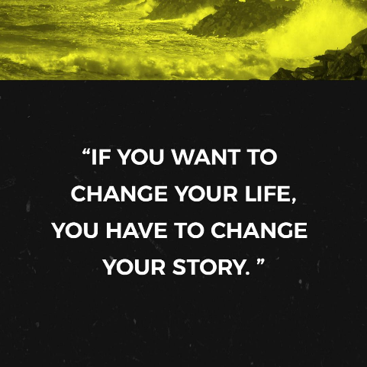

**“First Step of Faith” 1/5/25**



**“Take A Leap of Faith” 1/26/25**

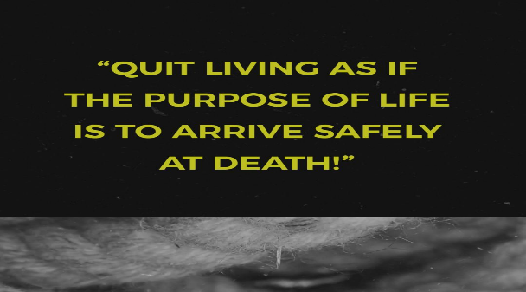

 **“Habit Builder” “Habit Builder” 1/12/25**

**“God Sized Vision” 1/19/25**

**“Making Time For God” 2/2/25**

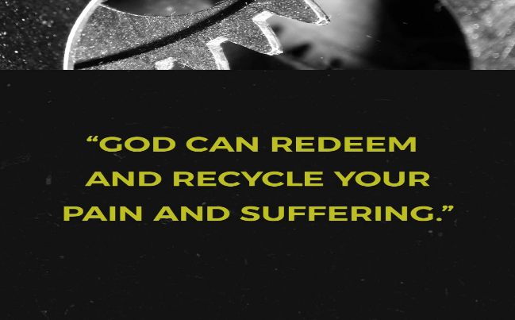

**Sermon Series January / February 2025**

**January 26th Week 5: Win The Day, “Take A Leap of Faith**

**February 2, 2025 Week 6: Win The Day, “Making Time For God”**

**February 9, 2025, Win The Day, Believe Big, Pray Big”**

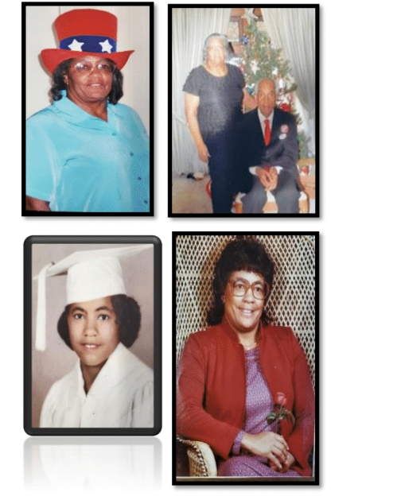  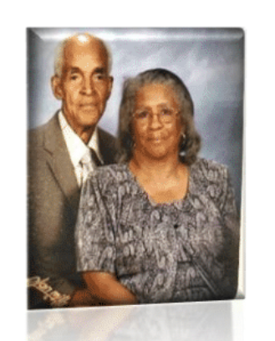

***Celebrating the 91th birthday of Emma Jackson***, Covenant Partner of New Life At Calvary.

Emma Jackson will be 91 years old on February 5, 2025. She is very happy to make it to be this age. Emma Jackson grew up in Summerville, GA, on a farm. She grew up with both of her parents, 2 sisters and 8 brothers. She is the youngest of all of them, making her child number 11. They are all deceased now.  As a girl she worked on the farm planting and gathering fruit, vegetables and cotton. In High School, Emma played on a basketball team in Lyerly, GA. She also ran track and did the high jump. Her father was a farmer and mom had a garden with cabbage, strawberries, black-eyed peas, peaches pears, peanuts, popcorn and much more. Her mom canned a lot of items in the Summer.

Emma went to Fort Valley State in Georgia and studied Home Economics. She was married to Dock (Glynn) Jackson after two years of college. Emma moved to Detroit with Glynn and they lived there 15 years. The couple then moved to Cleveland for work in the Fall of 1969. Emma was originally a part of the AME Zion Church and Glynn was Baptist. They couldn't agree upon churches but agreed upon being a part of the Presbyterian Church in Detroit by a friend's recommendation. His aunt recommended Calvary Presbyterian Church when they moved to Cleveland.

Emma and Glynn participated in many ministries in church including Sunday School, was President of the Women's Guild, Vacation Bible School and other Christian Ed programs. Emma Worked for the Cleveland School District as an Educational Aide and also worked with Head Start. Sometimes she made wedding cakes and likes to crotchet. She made all of her nieces an Afghan. She also enjoys crafts and sewing. Emma and Glynn had two children, Darryl and Denise. They have four grandchildren and a number of great-grandchildren.

**Happy 91st birthday Emma Jackson!**

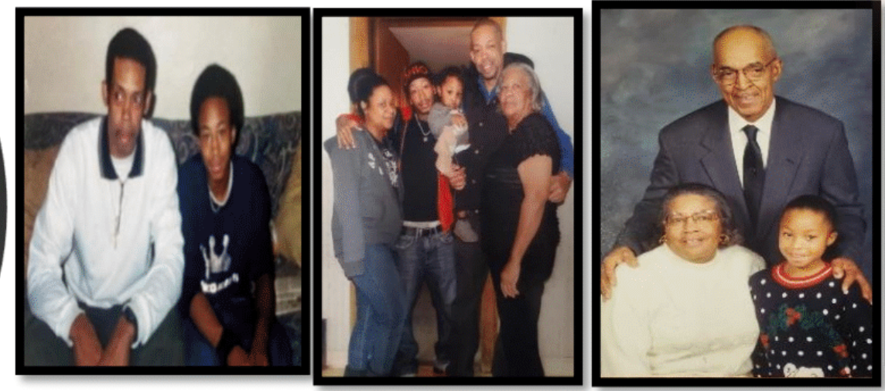

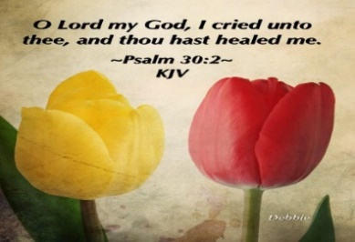

*Please send a card, call,* *pray for, and support our Sick and Shut ins and recuperating brothers and sisters in Christ. Thank you.*

**Jennie Brown** (1783 East 227th St, Euclid, OH 44117 216.785.9295)

**Stanette (Brown) Israel** (Ave. at Warrensville Care & Rehab, 4129 Interchange Corporate Center Rd. #143, Cleveland, OH 44128, 216.941.5211)

**Bessie Bryant** (Jennings Rehab Center, 10210 Granger Rd, #367 Garfield Hts 44125 216-246-3453)

**Minnie Doaty** (12005 Ablewhite Ave, Clev., OH 44108)

**Natalie Franklin** (daughter of Julie Wright cards only) (c/o Donnese Franklin, 4216 Colby Ave, Columbus, OH 43227)

**Marvin Hayes** (1817 Marloes East Cleveland, OH 44112

216.650.2312)

**Alfred Haywood** (St. Augustine 7801 Detroit Ave, Rm 421, Cleveland, OH 44102)

**Savannah (Robin) Hill** (Falling Water Healthcare Center, RM 236D, 18840 Falling Water Rd. Strongsville, OH 44136)

**Glynn Jackson** (13717 Southview Clev., OH 44120 216-921-3788)

**LaDonna Jessup** (Shaker Gardens Nursing & Rehab. 3550 Northfield Rd – 362A – Shaker, OH 44122 - 216-255-7693)

**Kent Kelton** (9308 Empire, Cleveland, OH 44108 216-672-2763)

**Mildred Little** (1344 East 90th St., Cleve., OH 44106)

**Fannie Ruffin** (8164 Dartmoor Rd, Mentor, OH 44060)

**Edna Swoope** (27100 Cedar Rd, Beachwood, OH 44122)

**Brenda White** (West Park Commons 4106 Rocky River Dr, Apt 207, Clev., OH 44135 216-377-7352)

**Janet Williams** (10516 Elgin Ave., Clevland, OH 44108)



**The White pillars candle in the chancel is**

**a reminder for us to pray for the safety of all**

**the men and women serving in the military.**

**It reminds us to pray for peace in our land**

**and all lands**

**Youth Zoom Classes on Mondays**

**Worship Class – A King Forever and Ever**

**Teacher (Pastor Antonia Martin)**

**Pastor will fill-in Monday**

(Grades PK-K) 2-5 years (6:00-6:30 pm)

(Grades 1-3) 6-8 years (6:30-7:30 pm)

(Grades 4-6) 9-12 years (7:30-8:30 pm)

(Grades 7-12) 13-17 years (8:30-9:30 pm.)

Zoom ID: 832 7903 1773 PC: 092683

**Monday 6:30 pm (Adult Class)**

**Joseph *When life’s a rollercoaster***

**Teachers: Marvin Rogers and Andrea Billups**

Zoom Meeting 891-1091-7393/2020 Zoom Call In 1-312-626-6799 891-1091-7393 # # 2020#

**Women with a Heart Bent Towards God**

**Teacher: Helen Britt**

**2nd Tuesday of the Month February 11th**

**Wednesday 7:30pm (Adult Class)**

**The Beatitude Project**

**Teacher: Pastor Antonia –**

Zoom Meeting 829-8003-5837/2020 Zoom Call In 1-312-626-6799 829-8003-5837 # # 2020#

**Wednesday 7:30 pm (Adult Class)**

**Teacher: Sylvia Fields**

**A King Forever and Ever**

Zoom Meeting 865-9998-5439/54321

Zoom Call In 1-301-715-8592 ID: 865-9998-5439 # # PW: 54321 #

**Wednesday 7:00 pm (Adult Class)**

Teachers: Reginald Woods – Romans Part 2

In person in the gym.

**Wednesdays 7:00 pm (Adult Class)**

**Teacher: Pastor Toby Emeritus (The Chosen Season 4 Episode 7)** Zoom Meeting 334-158-729/2020 Zoom Call In 1-312-626-6799 334-158-729# # 2020#

**Read The Bible in One Year/52 weeks/365 days - 7:30 pm January 21st**

**Genesis Chapter 1 Verse 8**

We will be using the NIV Version –

Teacher: Pastor Kellie

Meetings 1st, 3rd, 4th & 5th Tuesday of the month

Meeting ID: 82097918709 PW: 605886

Phone# 13126266799 82097918709 # # 605886 #

**Pledge Card for support of the 2nd Milestone of the**

**Building On Faith Capital Campaign of**

**New Life At Calvary Cleveland, OH**

A Capital Campaign is how we fund the future of New Life At Calvary. It challenges us to reach higher and dig deeper in order to meet the immediate and long-term needs of the church and the community. Like annual giving, giving to a Capital Campaign enhances the mission and ministry of the church through renovation and improvement of our church building.

Giving to the Capital Campaign is considered sacrificial giving. It does not come from our daily living expenses. Capital Campaign giving can be spread out over a three-year period to allow donors to manage their gifts according to their needs.

_____________________________________________________________________________

**I/We pledge in faith to support the 2nd Milestone of the Capital Campaign of New Life At Calvary listed by making the financial contribution listed below:**

**Total Amount of Pledge $_________________** (for those renewing the pledge see reverse side of this form)

**One-time Payment Date: ___________ Payments Over-Time**

Regular Payment Schedule expected:

$_____________ each week/month/quarter/year

**Method(s) of Payment**

* Cash or Check Enclosed
* Online Giving through New Life At Calvary
* (set up on the [www.nlac.tv](http://www.nlac.tv) website)
* Gift of Securities (see other side for more ways to give)

Start date: ______________ End Date: ______________

-or-

Other Payment Schedule described below:

__________________________________________________

__________________________________________________

__________________________________________________

Names: _____________________________________________________________________________________________________

Address: ____________________________________________________________________________________________________

City: _______________________________________________ State: __________________ Zip: ____________________________

Phone: ______________________________________________ Email: _________________________________________________

Signature Date of Pledge

____________________________________________________________________________________________________________

Signature Date of Pledge

**Methods of Giving to New Life At Calvary Capital Campaign, *Building on Faith Restoration***

**Cash or Checks**- Checks payable to New Life At Calvary, sent to 2020 E. 79th Street, Cleveland, Ohio 44103

**Online Giving**- One time or Recurring payment directly from a bank account. This is set up and managed from the Online Giving tab on the New Life At Calvary website (nlac.tv).

**Gifts of Securities**- Gifts of stocks, bonds, and other financial instruments can be arranged by contacting the NLAC steering Committee: Pastor Kellie C. Sullivan, Sylvia Y. Fields, Ruby Turner and Ella Thomas. When giving gifts of securities, please contact the Steering Committee with the donor’s name, the type of security name, and the number of shares, no later than the day the gift is made.

**Matching gifts**- Many employers will match charitable donations made by their employees. By using your company’s Matching Gift benefit, you may be able to multiply the amount of your donation. If you are affiliated with a company that matches gifts, please send the Matching Gift Form (usually attained by contacting your Human Resources Department), along with your donation to New Life At Calvary. The church will complete the form and return it to the company.

**Information pertaining to my companies matching gift program:**

___ I/We work for a Company that has a Matching Gifts Program.

___ The Matching Gifts Form is enclosed with this Pledge Card.

___The Matching Gifts form will be forwarded in the near future.

------------------------------------------------------------------------------------------------------------------------------------------

I/We pledge in faith to support the *Building on Faith Restoration Campaign* of New Life At Calvary by making the financial contribution listed on the reverse side of this form. My/Our contact information is on the reverse side. I/We have also signed indicating our commitment to complete this pledge. I understand that if we are a couple making this pledge both parties must sign this pledge.

**I/We made a pledge to the 1st Milestone. For the 2nd Milestone please do one of the following: (Check One)**

1. __________ Keep my/our pledge the same.
2. . _________ Increase my/our pledge to $________________.
   1. I/We plan on giving monthly, weekly, bi-weekly (please circle one).
3. I /We want to discuss giving a **Gift of Securities.**
4. I/We want to discuss doing a matching gift with my job.

1st Milestone givers please complete the contact information on the other side of this form. Thank you for your continued support.